**Experiment 1.3**

**Student Name:   Gaurav Kumar                                UID: 22MCC20177**

**Branch:   CC-DevOps                                                        Section/Group: 1/B**

**Semester:   I                                                               Date of Performance: 15/11/2022**

**Subject Name:** **Linux Administration Lab Subject Code: 22CAP-648**

1. **Create the directory DIR1 and inside this create another directory DIR2 and inside DIR2 create directory DIR3 Using a one single command. Show the path of the DIR3 directory. Create a blank file ABC.txt. Add the contents using cat command. Show long list of this directory also show hidden files.**
2. We can use –p option. This makes sure that mkdir adds any missing parent directories in the process.



1. To show the path of dir3 we can use pwd command.



1. To create a blank ABC.txt file we can use touch command.



1. Using cat and relative or absolute path of a file containing data with >> to append the content of cat file into destination file.

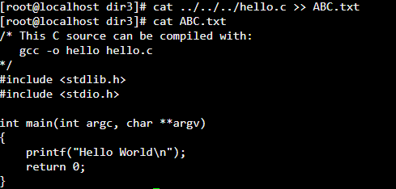

1. Using ll command in linux we can long list the content of the directory.



asasasa1. Open Linux terminal

1. 2. Write fdisk –l to view the partitions
2. 3. Select the partition using fdisk /dev/sda1
3. 4. Disk Partitions displayed with details
4. We can also view Disk partitions using lsblk. it displays block devices, when used with the -f option, it
5. prints file system type on partitions as well
6. now Creating primary partition and 2 extended partitions
7. **Learning outcomes (What I have learnt):** 
   * 1. **About fdisk and lsblk**
     2. **About disk partition**
     3. **Learn to create a new partition**

**Evaluation Grid:**

|  |  |  |  |
| --- | --- | --- | --- |
| Sr. No. | Parameters | Marks Obtained | Maximum Marks |
| 1. | Demonstration and Performance  (Quiz) |  | 22 |
| 2. | Worksheet |  | 8 |